Troubleshooting Guide: Linux Kernel & VMware Module Fix

Why we are doing this is because vmware does not properly work on ubuntu kernel 6.17.0-14-generic. So that’s why we are shifting our kernel to 6.8.0-100-generic.

1. Problem Description
After a system update, the Linux kernel version (6.17) became incompatible with VMware Workstation. This caused two main issues:
- Error 1: VMware could not compile kernel modules (vmmon and vmnet).
- Error 2: The system failed to boot, getting stuck at the GRUB Minimal BASH-like prompt.

2. The Solution (Step-by-Step)

Phase A: Recovering the Bootloader
To go to the grub(terminal) you need to restart the system. When the system is restarting phase then press the shift+Esc it will takes you to the grub menu
Identify Partition:
ls to see disks
then ls (hd0,gpt5)/ to find the Ubuntu files.
If yours boot file is in (hd0,gpt5) then simply put the following commands :
set prefix=(hd0,gpt5)/boot/grub
set root=(hd0,gpt5)
insmod normal
normal

Phase B: Stabilizing the Kernel
To prevent the error from returning, set a stable kernel (like 6.8) as the default using Grub Customizer:
First you need to add repo of grub-customizer by the following command :
sudo add-apt-repository ppa:danielrichter2007/grub-customizer -y
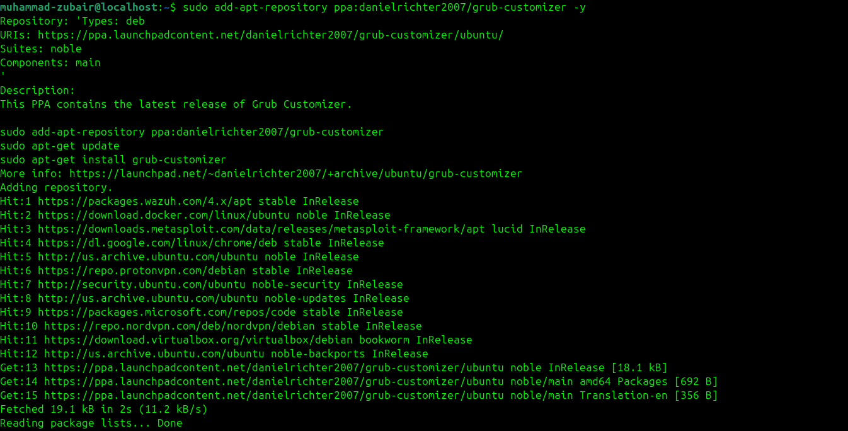
Then you need to update the list and install the grub-customizer by the command :
sudo apt update
sudo apt install grub-customizer
Now Run the grub-customizer by the following command :
sudo grub-customizer
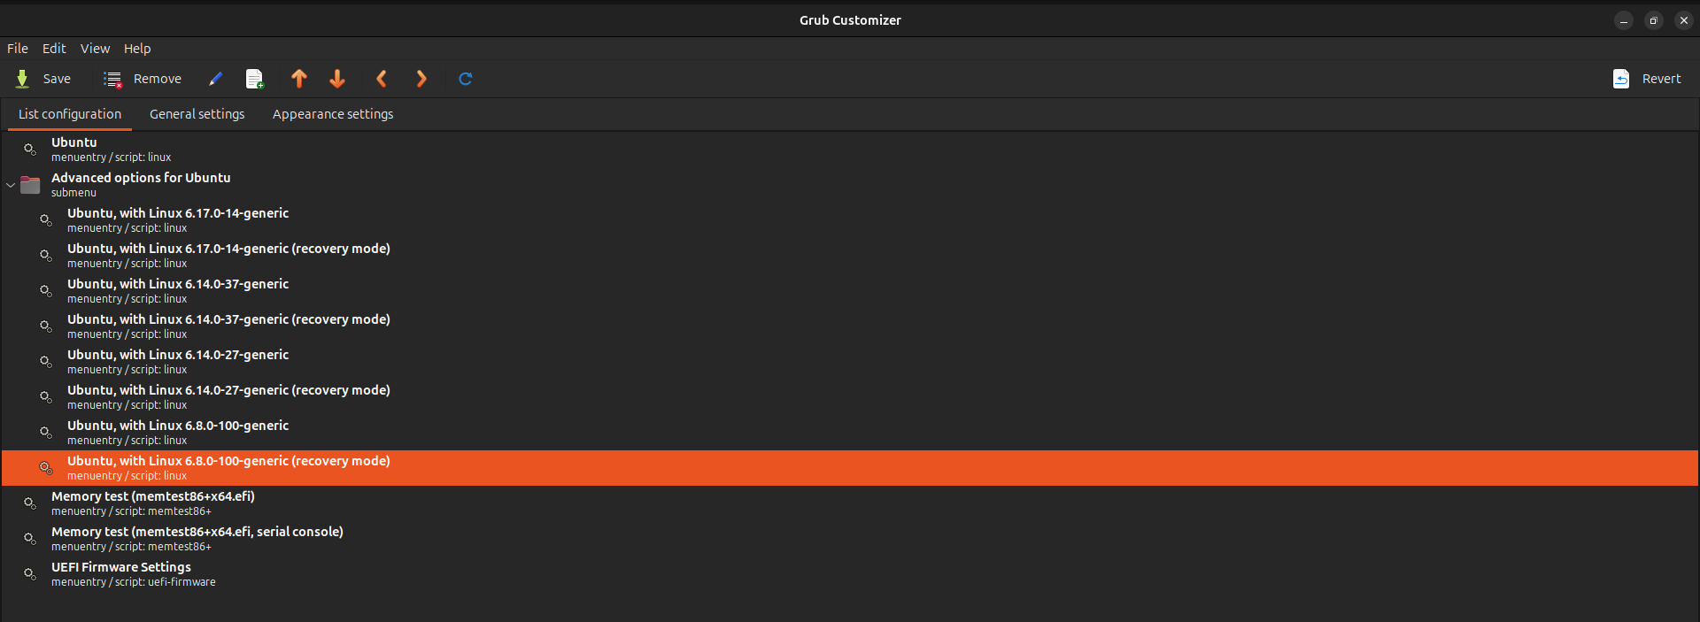

You need to up the “Ubuntu, with Linux 6.8.0-100-generic” by selecting one time click then press the up arrow key to keep it on the top.

After that restart your system.
Now you can see that the kernel is shifted from latest version(6.17.0-14-generic)
To 6.8.0-100-generic
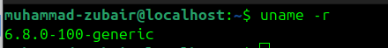
Now you are able to run your VMware smoothly.

Here You can see that Now it’s able to access the vmware

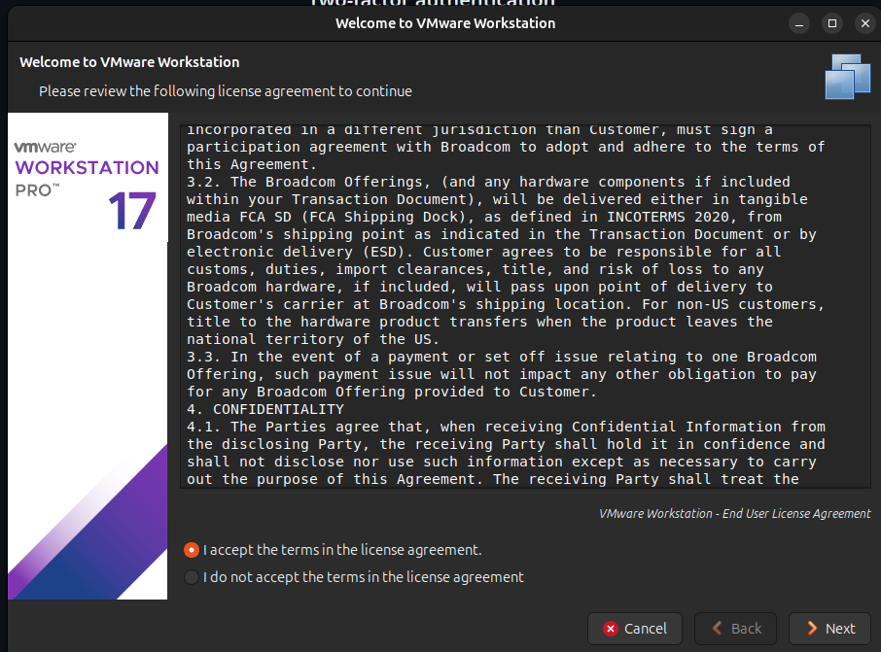
Note : If you face any problem then contact me!

GOOD LUCK!

